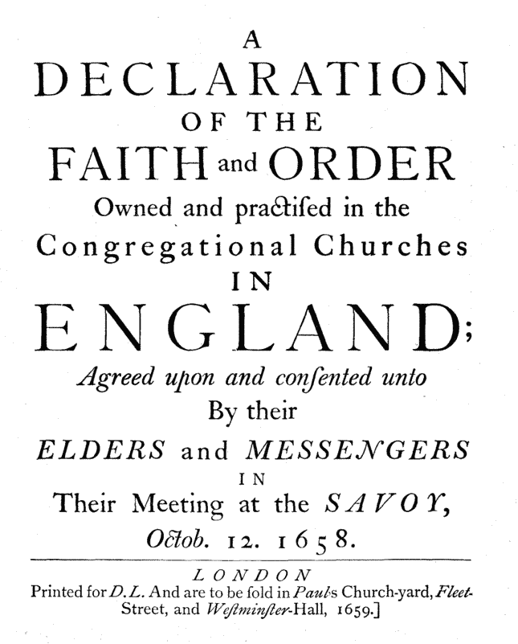
A

DECLARATION
OF THE

FAITH AND ORDER
Owned and practiced in the
Congregational Churches
in

England;
Agreed upon and consented unto
By their ELDERS and MESSENGERS
in
Their Meeting at the SAVOY,
Octob. 12. 1658.
The Savoy Declaration is a modification of the Westminster Confession to suit the Congregational polity.
Notes are included here that point out the differences in the two documents.
Page Updated: 12/11/2008

https://www.creeds.net/congregational/savoy/
https://www.the-highway.com/savoy_declaration.html

Savoy Declaration
The Savoy Declaration was a declaration and statement of faith prepared in 1658 by a conference of English Congregationalists who met at Savoy Palace, London. Its full title is A Declaration of the Faith and Order owned and practiced in the Congregational Churches in England. The declaration consisted of three parts: a preface, a confession of faith, and a platform of discipline. In matters of doctrine it was primarily a restatement (with some modifications) of the Presbyterian Westminster Confession (1646), but was specifically adapted to suit Congregational polity. The committee responsible for the declaration included Thomas Goodwin, John Owen, Philip Nye, William Bridge, Joseph Caryl and William Greenhill.

With respect to the WCF, the Savoy Declaration altered chapters 25 and 26, deleted chapters 30 and 31, inserted a new chapter 20, "Of the Gospel, and of the Extent of the Grace thereof," and added a platform of Congregational polity in the preface titled "Of the Institution of Churches, and the Order Appointed in them by Jesus Christ." The Savoy Declaration was designed to encourage agreement on important matters between churches; but, true to the nature of Congregational polity, it was not intended to be a legal or corporate instrument, as was the Westminster Confession.

Background
The Westminster Confession was adopted by the General Assembly of the Scottish Church in 1647 and ratified by the Scottish parliament in 1649. These acts of the English and Scottish parliaments were then nullified at the restoration of the Anglican episcopacy together with the British monarchy in 1660. After the Revolution of 1688, in which the intolerable Roman Catholic King James II was replaced by William of Orange, the Scottish parliament again ratified the Confession without change in 1690, to which the royal sanction was promptly granted by the new King.

In 1658, just two years before the restoration of the monarchy, about 200 delegates from the Congregational churches of England gathered in the Savoy palace in London to compose a revision of the Confession in which the principles of congregational independence and legal toleration would replace the established Presbyterianism implicit in the Confession's statements touching Church government and discipline.

https://www.theopedia.com/savoy-declaration

Full text of the Declaration with differences from the Westminster Confession of Faith
The Savoy Declaration - by Dr. John Owen
Creeds and Confessions of the Church

An addendum to the Westminster Confession made by John Owen.

The difference between this confession (or declaration) and the Westminster Confession is this chapter. There are some other small revisions, but this is the major change. This chapter does not appear in the Westminster Confession.

Chapter 20
Of the Gospel, and of the Extent of the Grace Thereof
1. The covenant of works being broken by sin, and made unprofitable unto life, God was pleased to give unto the elect the promise of Christ, the seed of the woman, as the means of calling them, and begetting in them faith and repentance: in this promise the gospel, as to the substance of it, was revealed, and was therein effectual for the conversion and salvation of sinners.

2. This promise of Christ, and salvation by him, is revealed only in and by the Word of God; neither do the works of creation or providence, with the light of nature, make discovery of Christ, or of grace by him, so much as in a general or obscure way; much less that men destitute of the revelation of him by the promise or gospel, should be enabled thereby to attain saving faith or repentance.

3. The revelation of the gospel unto sinners, made in divers times, and by sundry parts, with the addition of promises and precepts for the obedience required therein, as to the nations and persons to whom it is granted, is merely of the sovereign will and good pleasure of God, not being annexed by virtue of any promise to the due improvement of men’s natural abilities, by virtue of common light received without it, which none ever did make or can so do. And therefore in all ages the preaching of the gospel hath been granted unto persons and nations, as to the extent or straitening of it, in great variety, according to the counsel of the will of God.

4. Although the gospel be the only outward means of revealing Christ and saving grace, and is as such abundantly sufficient thereunto; yet that men who are dead in trespasses, may be born again, quickened or regenerated, there is moreover necessary an effectual, irresistible work of the Holy Ghost upon the whole soul, for the producing in them a new spiritual life, without which no other means are sufficient for their conversion unto God.

https://www.apuritansmind.com/creeds-and-confessions/the-savoy-declaration-by-dr-john-owen/

